**Searching for a Specific User and Updating the User Information.**

**Developer Name: BANOTHU VEERANNA**

This document contains contents for:

* Project Description
* Flow of the Application
* Core concepts used in project
* Conclusions.

**1.Project Description:**

* Create a Spring MVC web application that will retrieve users based on their user ID.
* The retrieved user data will then be edited in a form and updated in the database.
* The entire database processing has to be done using Hibernate. Front pages will be made in JSP.

**2.Application Flow:**

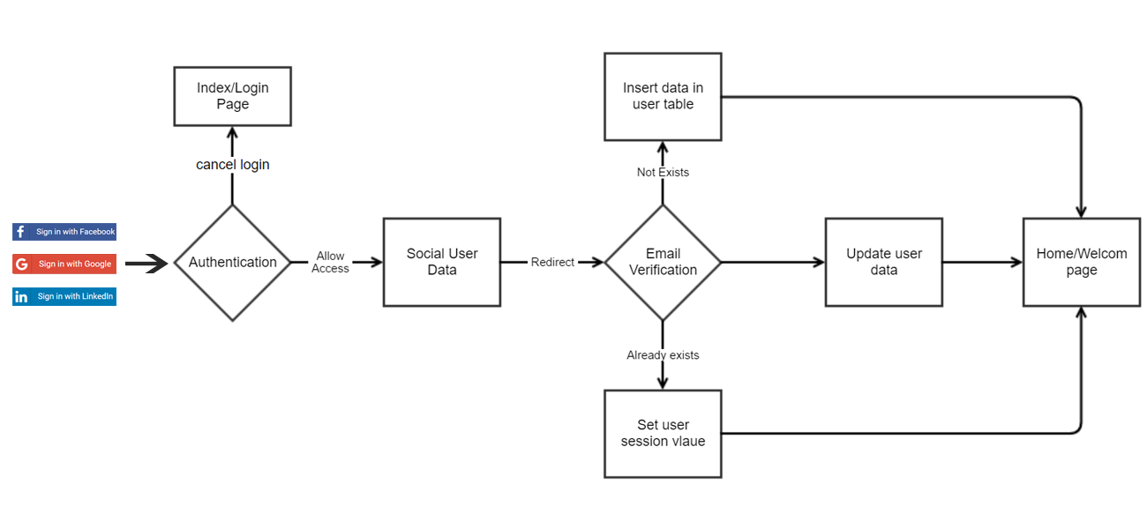

**4.Core concepts used in project:**

● Eclipse as the IDE  
● Apache Tomcat as the web server  
● Spring MVC with Hibernate, log4j, and MySQL Connector

**Conclusion:**

* This project is designed for Searching for a Specific User and Updating the User Information.